Electronic Signals

Subject:  Related Subjects: | Grade Level(s):  Length of Lesson: | Type: Inquiry / Design / Project  Keywords: Signal, Wave, AC, DC, Sine,

Lesson Overview
In understanding how electrical signals work and help the world around us, students will use microcontrollers to see how different signals effect LEDs.

Lesson Focus
What is the central question or phenomenon being investigated? What problem are they trying to solve?

Lesson Objective(s) | By the end of this lesson, students will…  - Learn the concepts of attraction, repulsion, friction, polarity, and charge.

Lesson Timing

Time | Description
2:30-2:35 | Introduce the Lesson  - Ask Pre-Lesson Questions  - Go Over Vocab
2:35 | Person of Color
2:35-3:00 | Lesson
3:00-3:15 | Lesson Wrap Up & Assessment
3:15-3:30 | Lesson Cleanup

Materials | - Leds  - USB A to B  - Arduino  - Arduino Sketch  - Wire + Wire cutters  - USB Outlets
Instructor Prep | - Step 1
Related Resources | - List related lessons/ppts etc available from USC or outside, trusted orgs

Lesson Plan

Introduction
  - What is electricity?
  - What are sources of Electricity?
  - What is Magnetism

Procedure

Prior to class, upload an Arduino sketch to the Arduinos that allows for different PWM signals for different digitals outs on the Arduino.
- Using a usb-a to usb-b cable, give your Arduino power.
- With a bread board, connect your Arduino’s ground pin and connect it to the negative rail of the breadboard.
- Connect the different active digital pins to pins on the breadboard.
- Using LEDs, connect the cathode to the ground rail of the breadboard and the anode to the digital outs on the breadboard.
- Observe, Question- Ask students what they think is happening in the activity/have them make hypothesizes.
- Explanation- Explain in detail, in conjunction to the vocab words, what is happening in the activity.

Wrap-up
The purpose of the survey is to let us know your opinions about today’s project. Remember there are no right or wrong answers.

 |  | Strongly Disagree | Disagree | Undecided | Agree | Strongly Agree
1 | The project increased my interest in science
2 | After this project, I am more confident in doing science

3. What does an electrical technician do?

4. What is a signal?

5. What are sources of some electrical signals?

Lesson Background for Teachers

Suggested Real-World STEM Connections

Person of Color

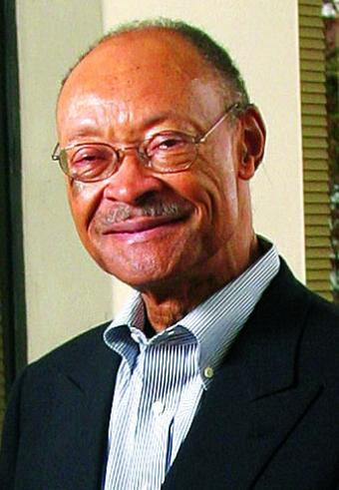
Name: Frank Greene
Years: 1938-2009
Brief- Greene stood among technology giants Robert Noyce, David Packard, William Hewlett and the Varian brothers as one of 63 inductees into the Silicon Valley Engineering Hall of Fame, conferred by the Silicon Valley Engineering Council. He was also hailed as one of the first black technologists, breaking the color barrier in local industry.

He developed high-speed semiconductor computer-memory systems at Fairchild Semiconductor R&D Labs in the 1960s. He started two technology companies and later founded NewVista Capital, a venture firm with a special focus on minority- and female-headed firms. Its headquarters, now in Sunnyvale, were previously located in Mountain View and Palo Alto.

Lesson Variations and Options
Include descriptions of alternative methods or ways to present things.

Explanation
Describe the background concepts and explanations behind the lesson. This can be more in depth than a teacher/instructor would actually share with students.

Key Concepts and Vocabulary
- Signal
  - A high frequency electrical impulse that can be transmitted or received.
- Wave/ Sine Wave
  - A wave is an oscillation accompanied by a transfer of energy that travels through a medium
- AC
  - Alternating current (AC), is an electric current which periodically reverses direction, whereas direct current (DC, also dc) flows only in one direction.
- DC
  - DC (direct current) is the unidirectional flow or movement of electric charge carriers (which are usually electrons).
- PWM
  - Pulse-width modulation (describe a square wave)
- Transistor
  - An ‘electrical switch’ used to make many types of oscillators.
- Frequency
  - The rate of oscillation measured in hertz.

Intro into micro-controllers
-Signals
Digital
Analog

Safety Notes
- Safety instruction

